Paul Polsinelli

IFT 220 – 90917a

8/26/20

Lab 1

1. Open control panel

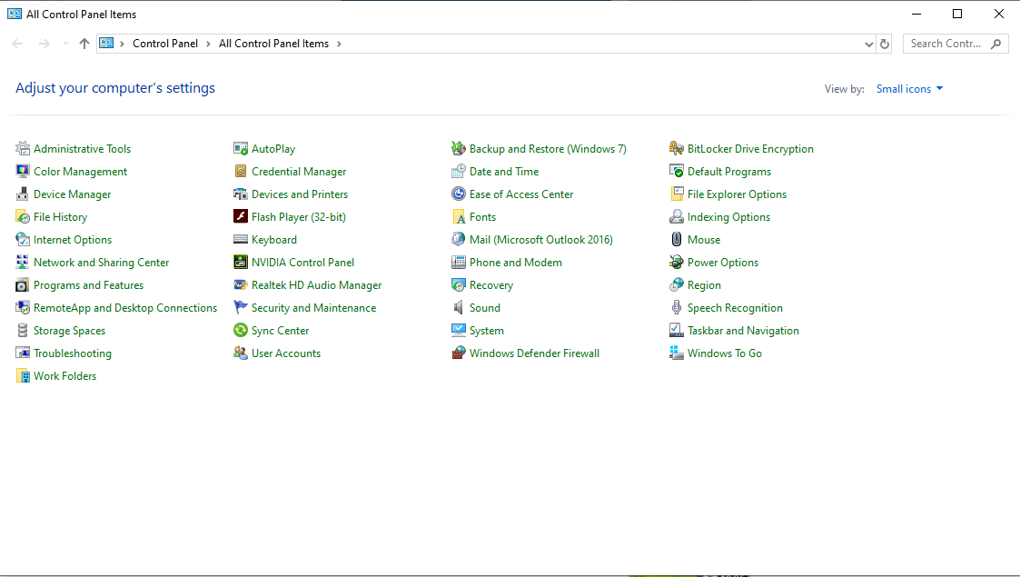

1. Open Programs and Features

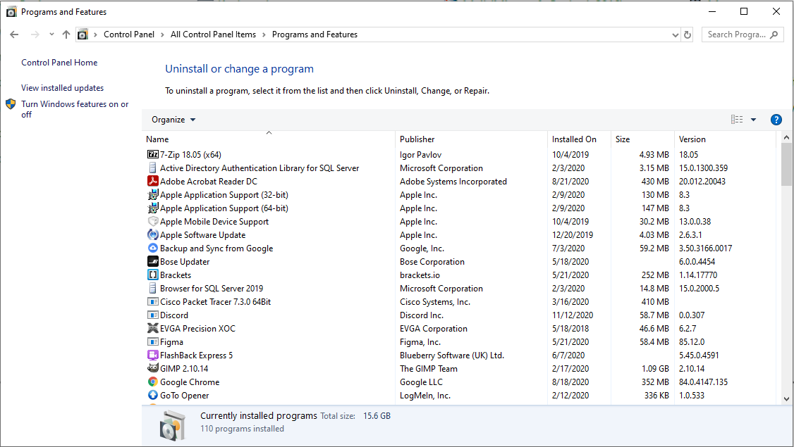

1. Click Turn Windows features on or off, open and select the Hyper-V boxes, and click OK

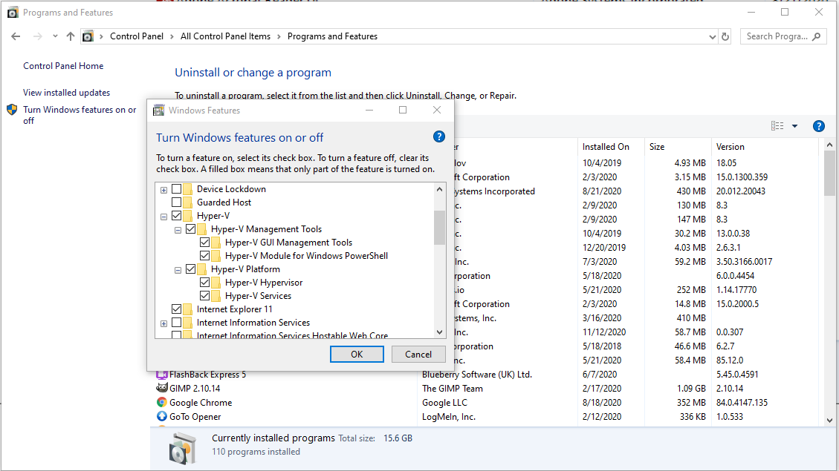

1. Choose to restart when the dialog box asking you to do so appears. After the reboot, start typing “Hyper V” in the search box and choose Hyper V Manager and open it.

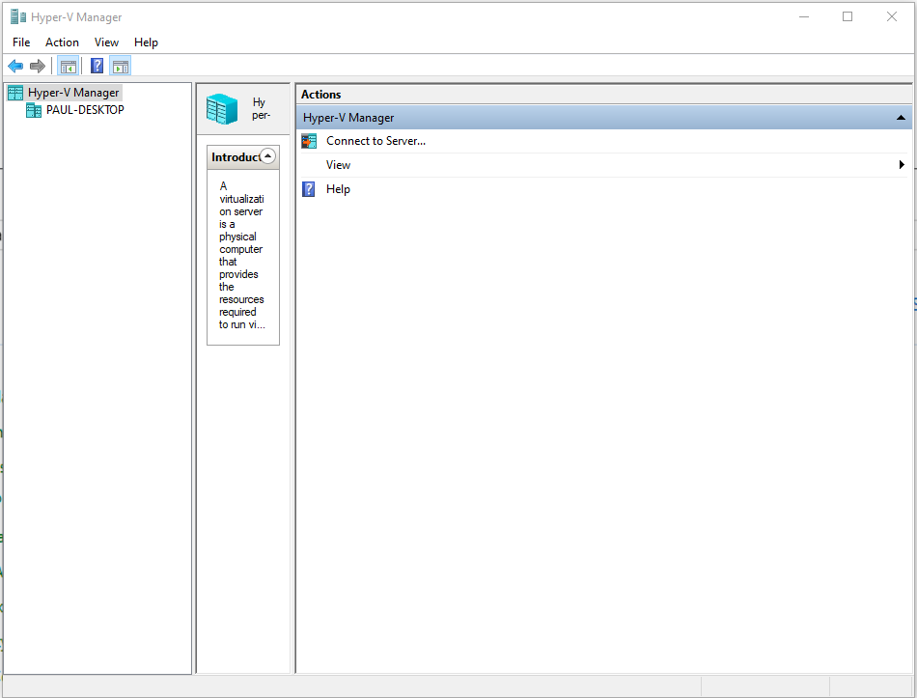

1. Right click on your computer name and choose New… Virtual Machine. The install wizard will begin.

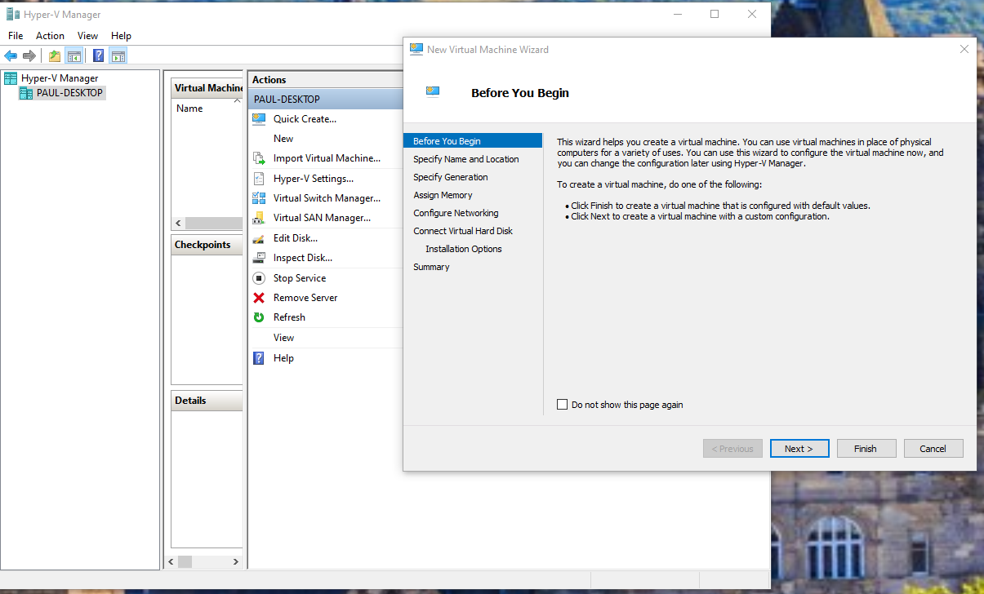

1. Click Next, name your VM, click the box to create your own folder to store the VM, and click Next again.

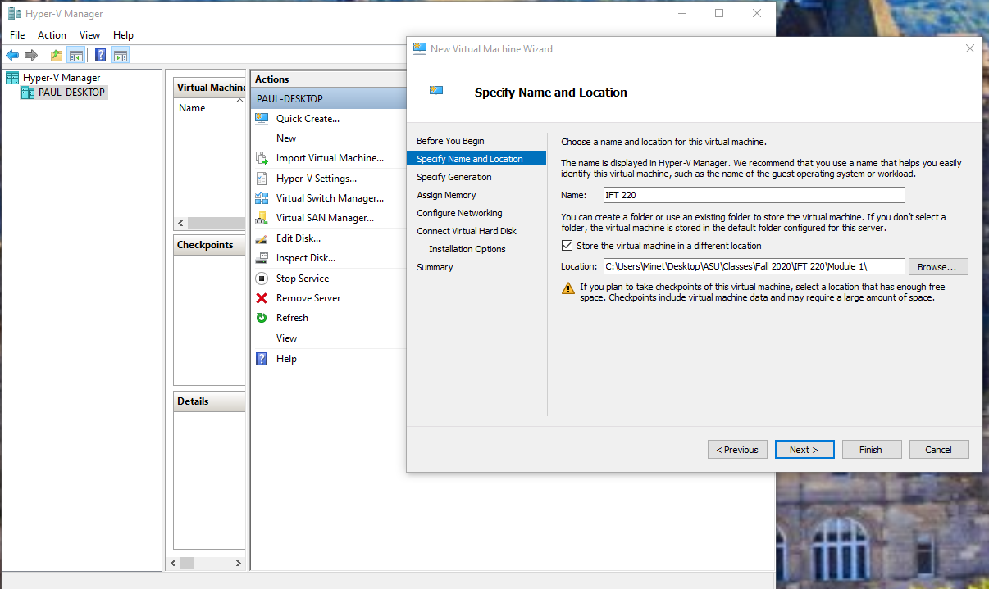

1. Choose your generation of machine. I chose Generation 2 to take advantage of the most up to date tech. Click Next.

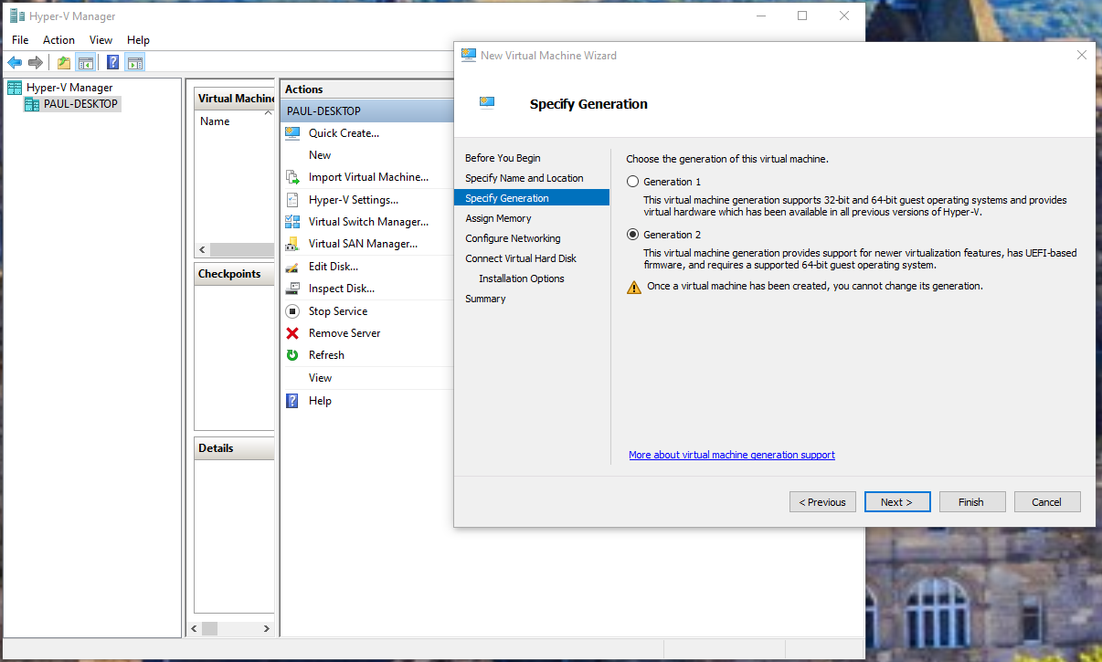

1. Assign memory. I chose 2GB as was recommended when I installed VMware workstation in another class. Click Next.

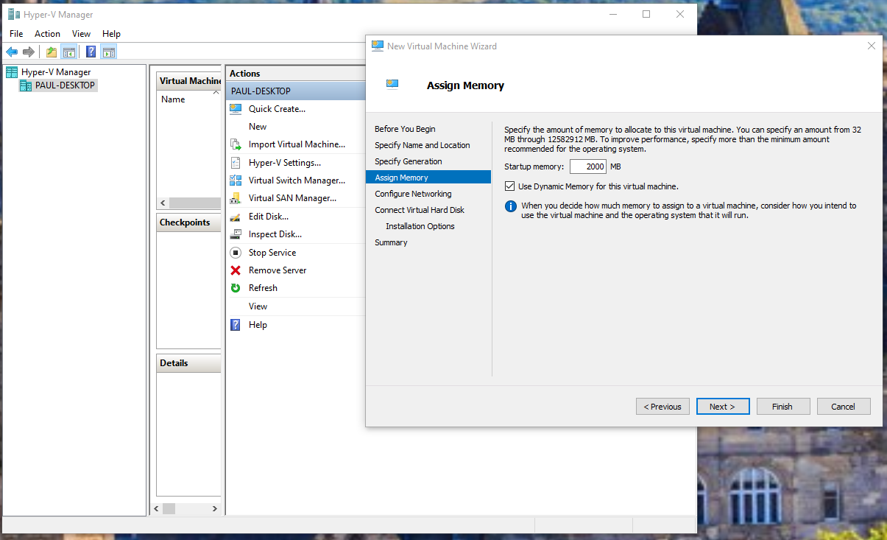

1. Configure Network. The options are Not Connected and Default Switch. I chose default. Click Next.

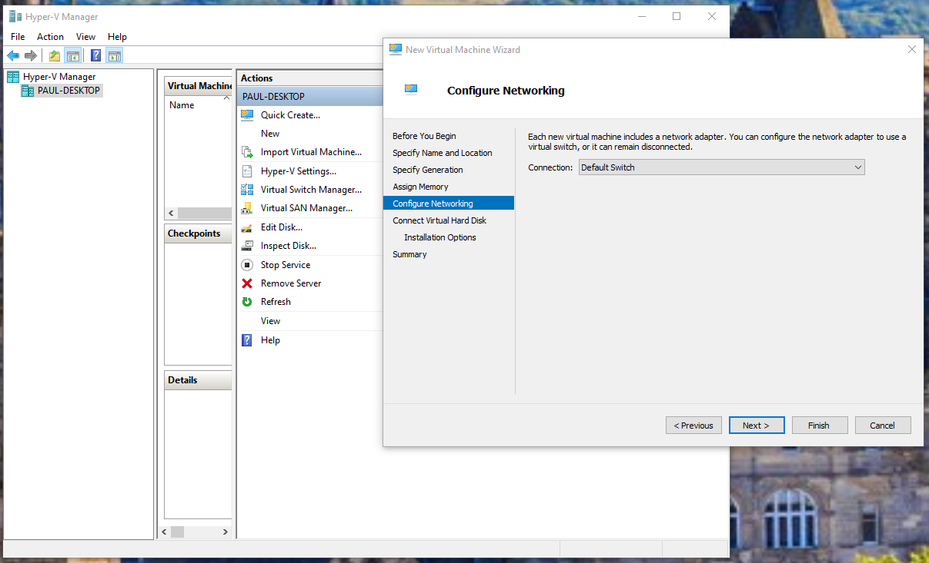

1. Choose the name, size, and location of the virtual hard disk. I used the default name, my D:\ drive as it has lots of free space, and 20 GB as was recommended from a previous class on VMware workstation. Click Next.

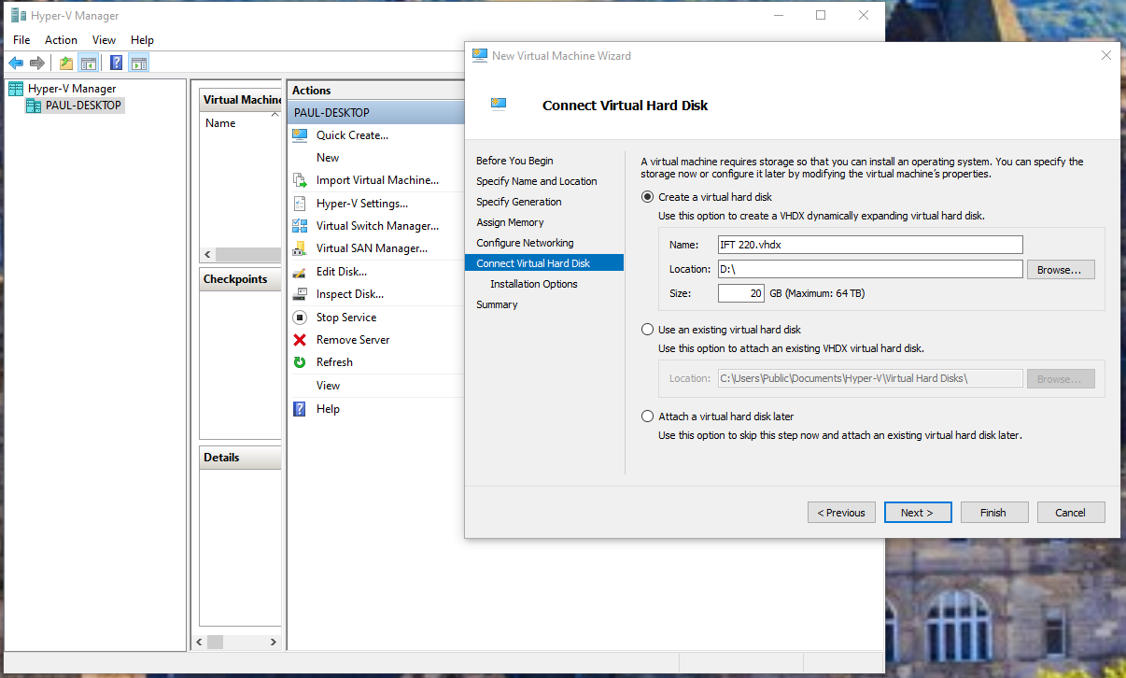

1. Choose your operating system to install. I chose Install an operating system later, as I do not have any more licenses on my windows. I have the school provided windows installed on Oracle Virtual Box, installed in a previous class, which I will use for this class and provide a screenshot of below. Click Next.

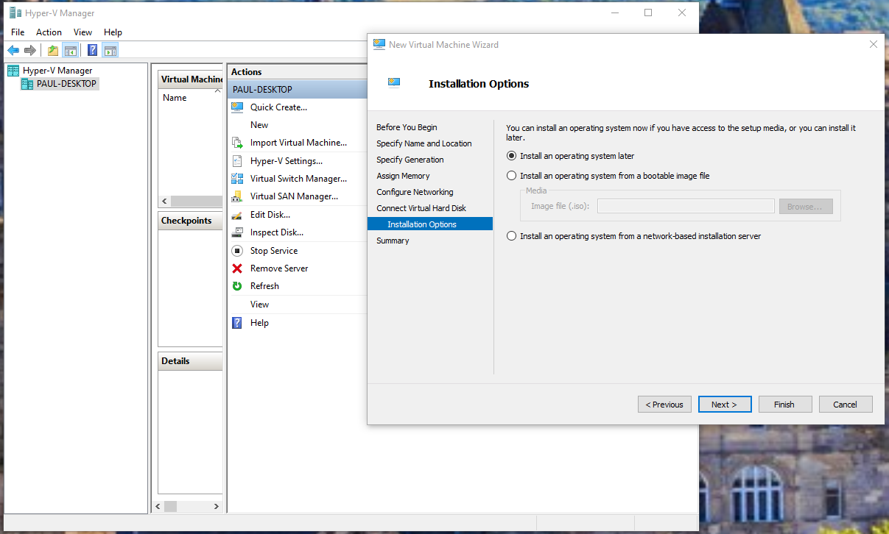

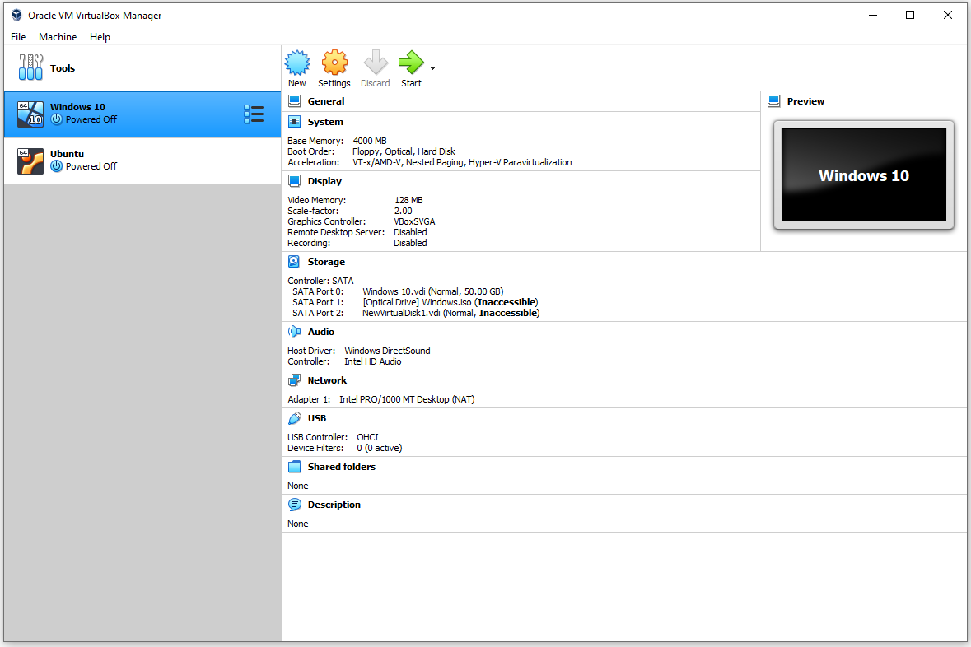

1. Click finish.

